**Course Name**  Data Visualization

**Name**  Vibha Desai

**Date** 12th February 2018

**Tableau Lab 2: Charting Lab**

1. Bar Chart

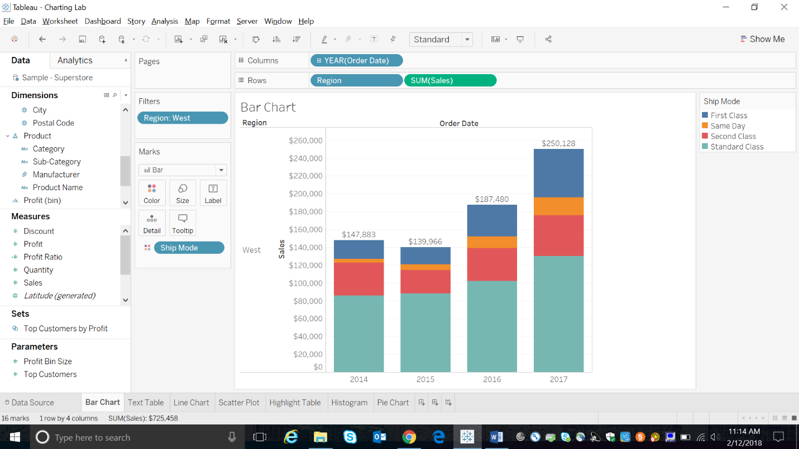

Figure 1: Bar Chart

Bar in bar charts provide a fantastic way to compare a measure against a goal or to display two measures against one another. Building a bar in bar chart in Tableau is not incredibly difficult, but it does require a few specifics steps that can be hard to remember if you haven’t built them a lot.

A bar chart uses the Bar mark type. Tableau selects this mark type when the data view matches one of the two field arrangements shown below. You can add additional fields to these shelves.

1. Text Table

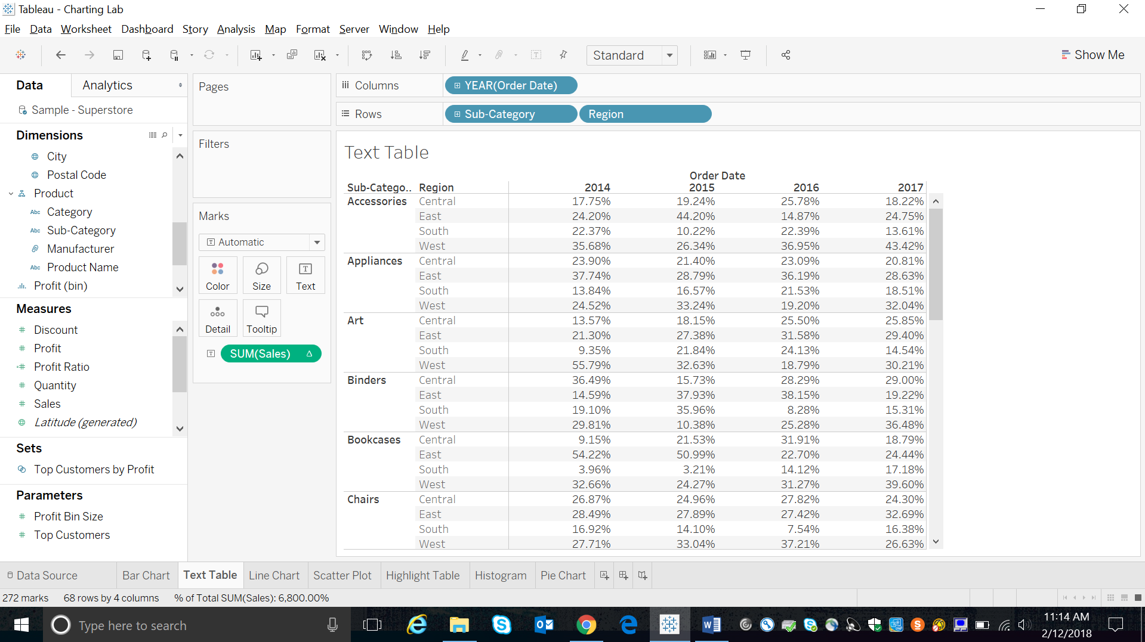

Figure 2: Text Table Chart

A text table uses the text mark type. Tableau uses this mark type automatically if the view is constructed using only dimensions. Text tables are also known as Crosstabs views and are typically used to show important numbers at a glance. They are very similar to Excel's pivot table.

1. Line Chart

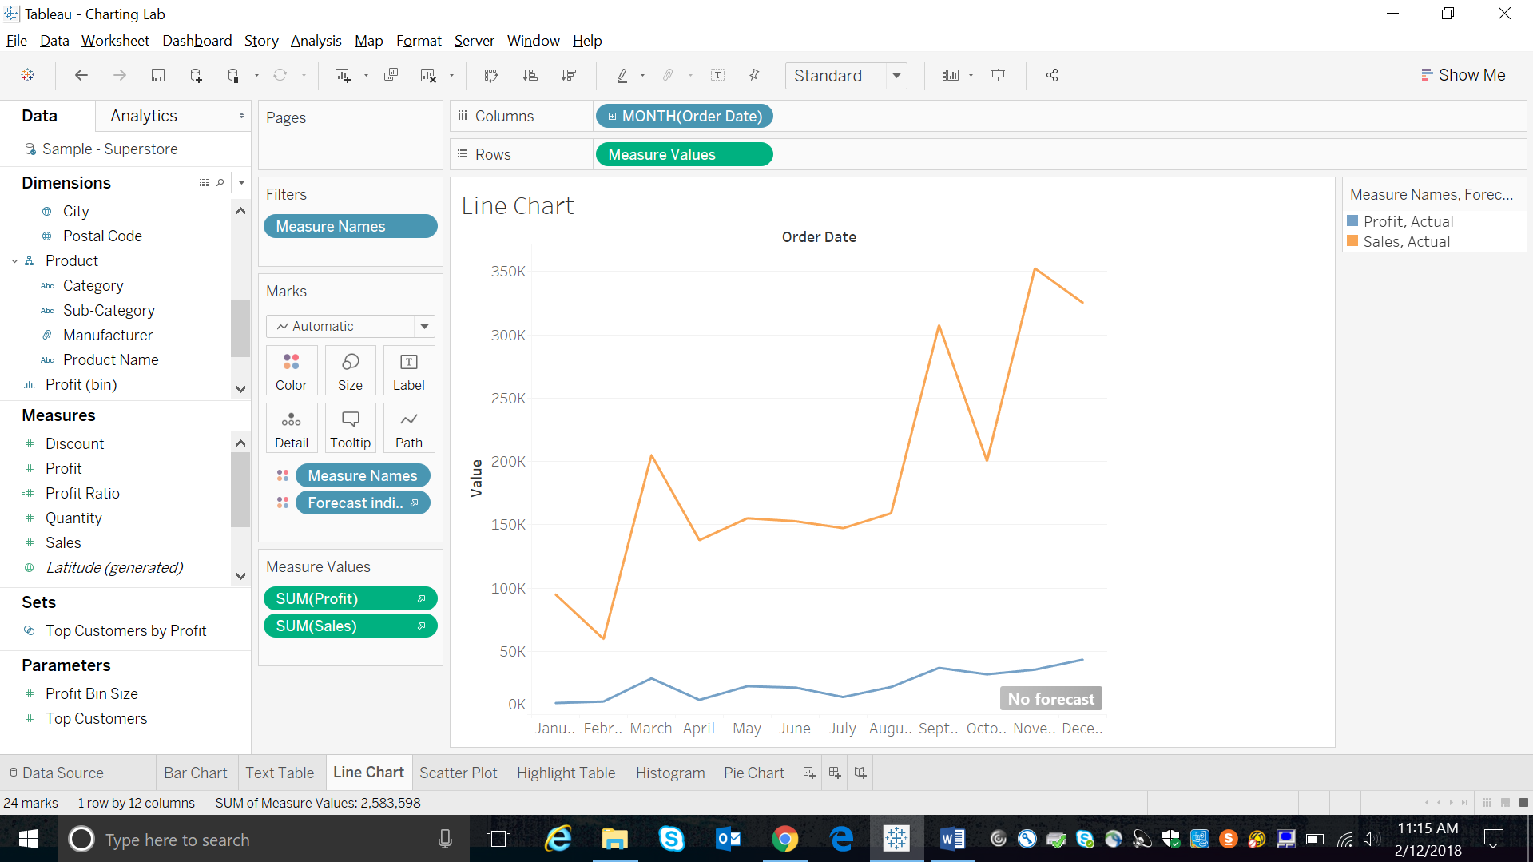

Figure 3: Line Chart

Line charts connect individual data points in a view. They provide a simple way to visualize a sequence of values and are useful when you want to see trends over time, or to forecast future values. When you are displaying multiple measures in a line chart, you can align or merge axes to make it easier for users to compare values.

1. Scatter Plot

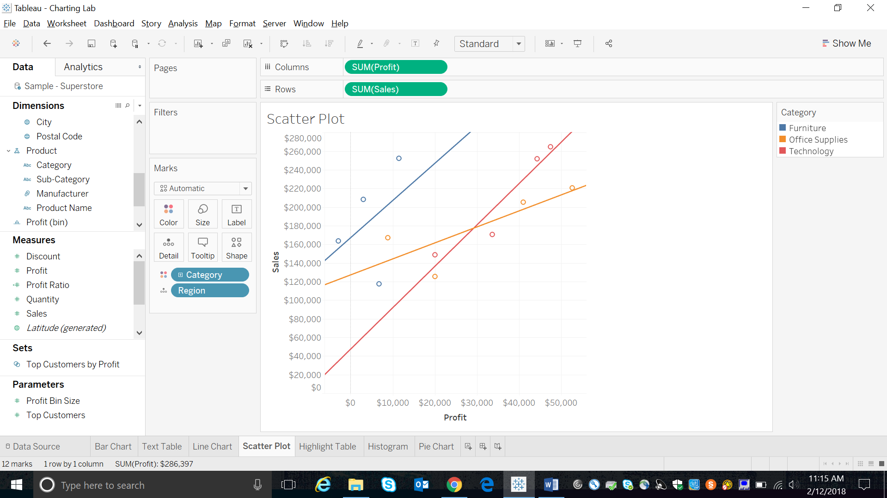

Figure 4: Scatter Plot

Scatter plots are used to visualize relationships between numerical variables. In Tableau, you create a scatter plot by placing at least one measure on the Columns shelf and at least one measure on the Rows shelf. If these shelves contain both dimensions and measures, Tableau places the measures as the innermost fields, which means that measures are always to the right of any dimensions that you have also placed on these shelves. The word "innermost" in this case refers to the table structure.

1. Highlight Table

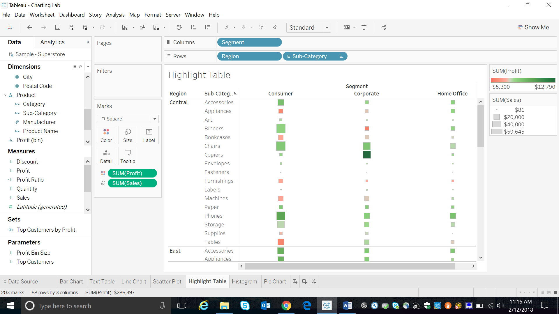

Figure 5: Highlight Table

Highlight tables are used to compare categorical data using color. In Tableau, you create a highlight table by placing one or more dimensions on the Columns shelf and one or more dimensions on the Rows shelf. You then select Square as the mark type and place a measure of interest on the Color shelf. You can enhance this basic highlight table by setting the size and shape of the table cells. To create a highlight table to explore how profit varies across regions, product sub-categories, and customer segments

1. Histogram

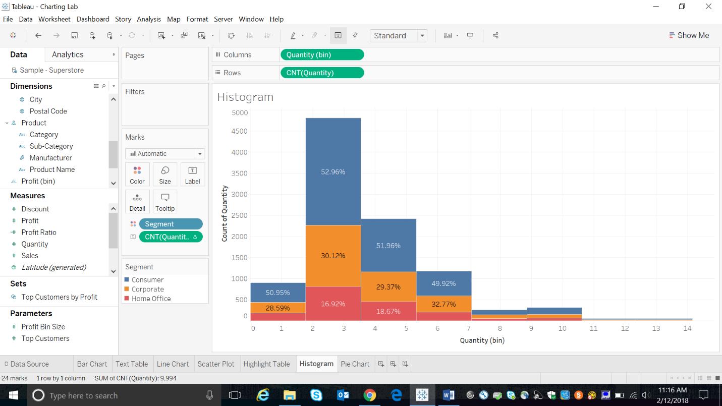

Figure 6: Histogram

A histogram is a chart that displays the shape of a distribution. A histogram looks like a bar chart but groups values for a continuous measure into ranges, or bins.

1. Pie Chart

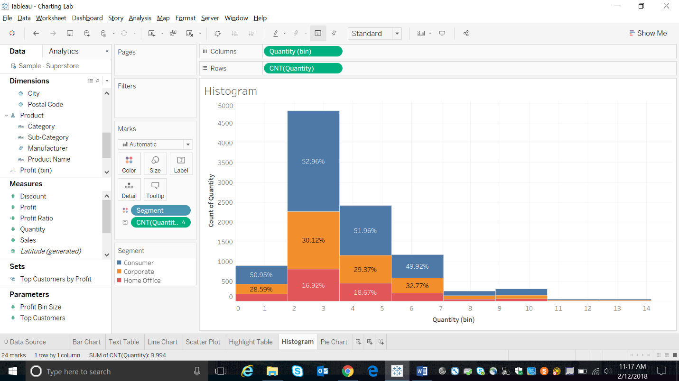

Figure 7: Pie Chart

Pie charts are used to show proportions of a whole.